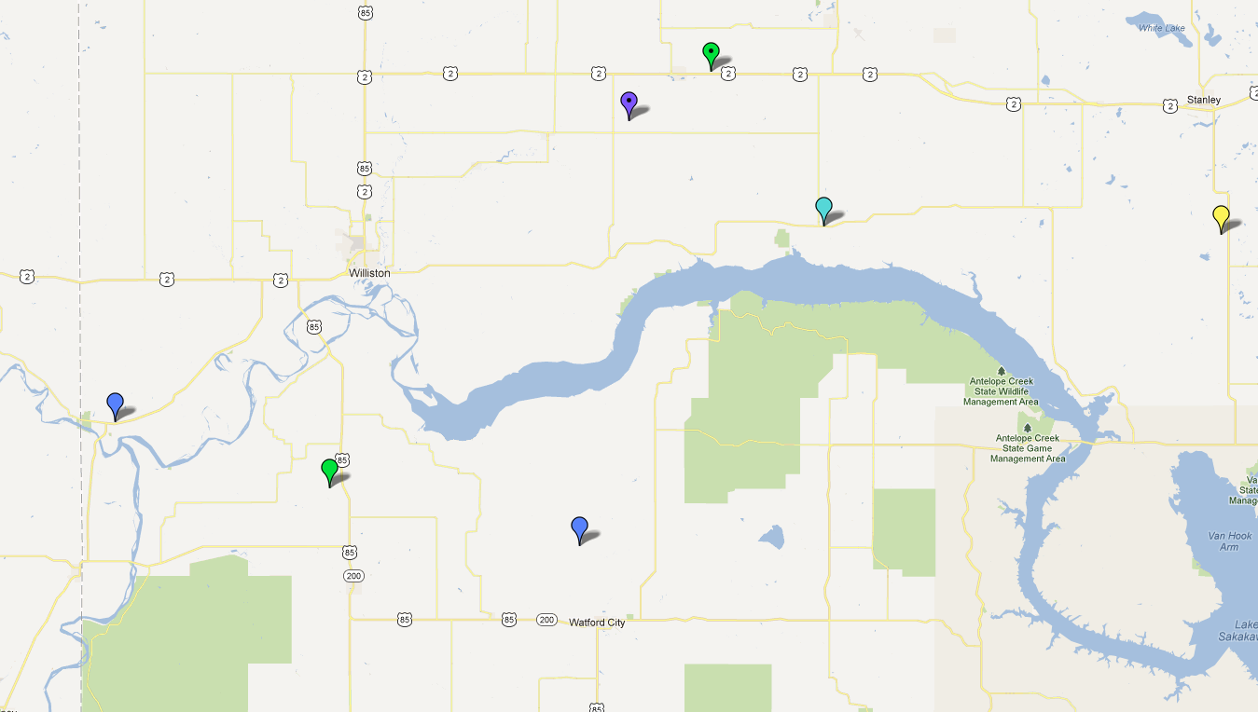

**Foss 12-11**

**Vinger 1**

**Evans SWD 1**

**Larmer 6-6**

**Bruins SWD 1**

**BA Green 1-6**

**Zimmerman SWD**

Ray